**BP315 Business Sub-Process Design Document**

**Label Management**

**Cross Industry/Supply Chain Management**

**Recipe Development**

Table of Contents

1 Overview 3

1.1 Change History 3

1.2 RASCI 3

1.3 Approval Detail 3

1.4 Other Related Documents 3

2 Business Process Overview 4

2.1 High level requirements 4

2.2 Key Value Drivers for the Business Process 4

2.3 Leading Practice Inputs 4

3 Business Sub-Process Description 4

3.1 Business Sub-Process diagram 5

4 Sub Process Activities 6

4.1 Activity List 6

4.2 Inbound Communication 6

4.3 Outbound Communication 7

4.4 Test Conditions 7

5 Sub-Process Variation 7

5.1 Geography/Legal Entity Led 7

6 Role Definition & Organisational Impact 7

6.1 Role/Skill Class Inventory 7

6.2 Role Summary 8

6.3 Organizational Impact 8

7 Process Fitness & Gap Analysis 8

7.1 Process Fitness 8

7.2 Gap Analysis 8

8 RICEFW 9

8.1 Reports 9

8.2 Interfaces (Inbound / Outbound) 9

8.3 Conversions 9

8.4 Enhancements 10

8.5 Forms 10

8.6 Workflows 10

9 Integration Points 11

9.1 Integration Issues 11

9.2 Other issues 11

# Overview

In this business process document, Label Management for a process industry with respect to specification and recipe development is documented.

Labeling is the final product information which needs to displayed on the product, which also serves the purpose of regulatory requirements pertaining to the product.

## Change History

|  |  |  |  |  |
| --- | --- | --- | --- | --- |
| Ver. | Date | Summary of Changes | Author | Transport Number |
| 1.0 | 28-11-2019 | Reviewed by Deepak Kumar K | Pushpadanta Jain |  |
| 1.1 | 01-04-2010 | Format changes and Minor corrections Reviewed by Deepak Kumar K | Pushpadanta Jain |  |

## RASCI

|  |  |  |  |
| --- | --- | --- | --- |
| RASCI | Role | Name | Phone |
|  |  |  |  |
|  |  |  |  |

R: Responsible; A: Accountable; S: Support; C: Contribute; I: Information;

## Approval Detail

|  |  |  |  |
| --- | --- | --- | --- |
| Review # | Date | Name & Position of Approver | Signature |
|  |  |  |  |
|  |  |  |  |

## Other Related Documents

|  |  |
| --- | --- |
| Related Document | Comment |
| BP315_Specification and Recipe Development_1909 |  |
| BP310_Label Management_1909 |  |

# Business Process Overview

In a process industry, once the product formulation is carried out in the recipe then the product will be handed over to manufacturing via bill of material generation and master recipe generation. In the subsequent step, For a final product to be successfully launched to the market it is very much necessariy to have a packaging label created, companies are in a need of efficient tool which can be used as input for final product label creation and label artwork.

Labelling is the written information on the packages. This consist of important information which is to be communicated to customers. These labelling information can consist of

* Ingredient contents of the product,
* Declared information on diet suitability (vegetarian), allergen information (milk, eggs, nuts), religious certificate compliance (halal/kosher) etc,
* Nutrient Facts/information i.e key constituents such as Vitamins, Proteins, Carbohydrates etc.
* Marketing statements, ‘Use By date’ ‘Preparation Guidelines’ Storage Guidelines’ which needs to be printed on the final product packaging.
* It can also contain the Regulatory advisories, Labelling requirements can come from the regulatory bodies.. For any product in the market, it has to adhere to guidelines of their country’s regulatory bodies.

This use case will describe the process of label set creation, different types of labelling contents, and review and approval of the label set and then printing it to packaging label which is compliant with local/international regulations.

## High level requirements

|  |  |
| --- | --- |
| **Sr. No.** | **Requirement Long Description** |
| 1 | The ability to create new label or copy from an existing |
| 2 | Ability to display RDA per region |
| 3 | Efficient ways of generating Label set via recipe or specification, |
| 4 | Functionality which allows in adding footnotes and marketing statements |
| 5 | Ability to have formula specific labeling data linked across multiple pack sizes / SKUs |
| 6 | Ability to select & evaluate Packaging Materials for compliance in specific Target Markets |
| 7 | Ability to have label generated in multiple languages. |
| 8 | Specify specific allergens information and dietery requirements |

## Key Value Drivers for the Business Process

* Reduced chances of non-compliance and penalties by authorities
* Cost Reduction by decreasing rework

## Leading Practice Inputs

* Frequent changes in Product, Regulatory & Compliance rules
* Accurate Product information, marketing statements to help consumer

# Business Sub-Process Description

The Complete Sub process of Label Management use case in SAP described in the next sections

## Business Sub-Process diagram

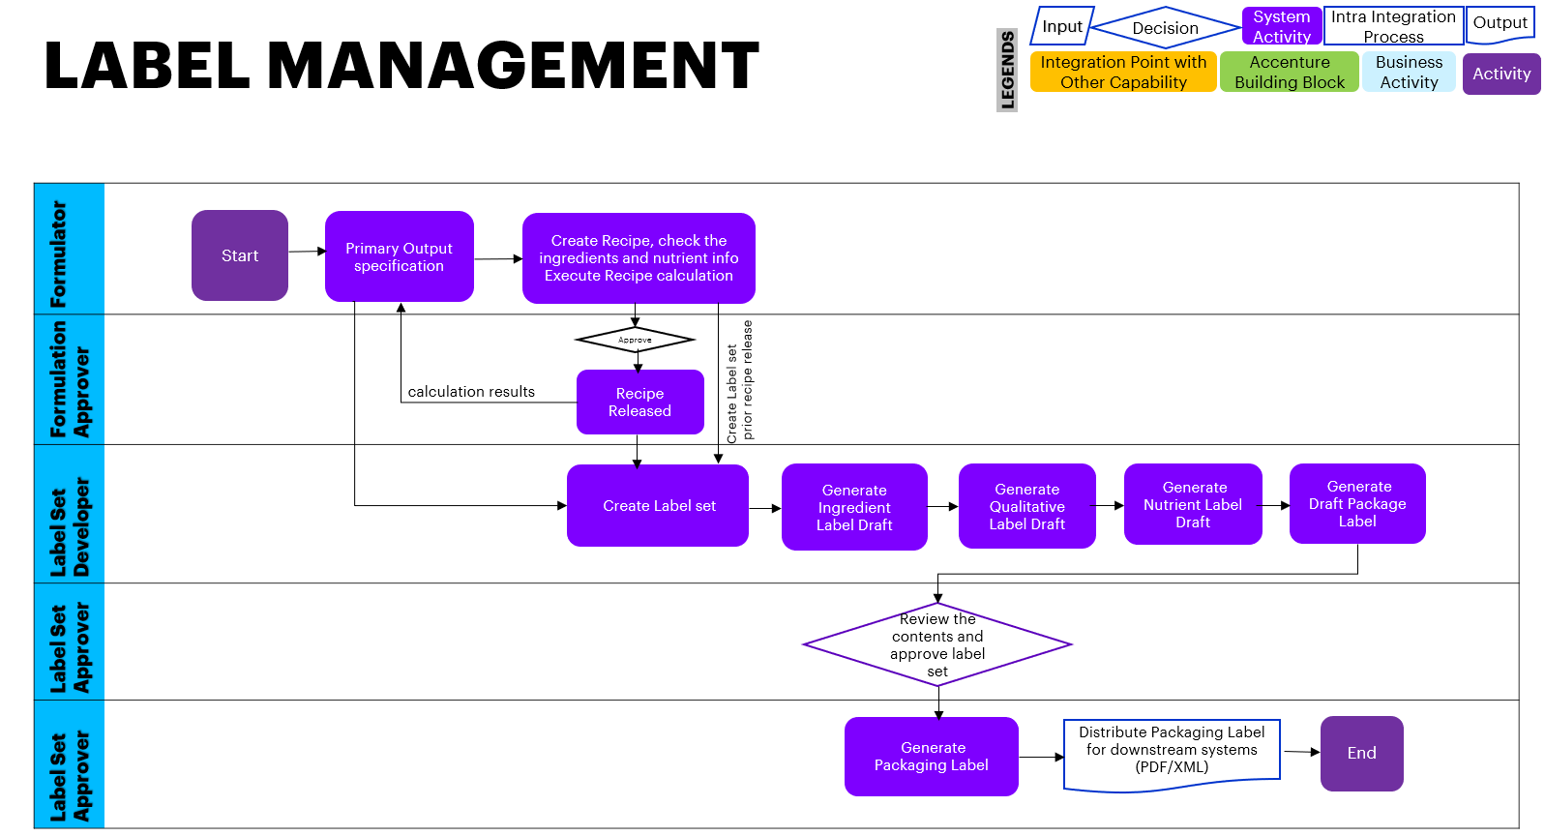

**Labeling Process :**

Labels are required for different purposes depend on the product to be labeled, It can contain product properties, and its packaging. Also it is required to maintain safety information for relevant substances containing safety symbols and safety information.

In certain cases specific labels are required for individual customers. This process describes how to create all of this data for labels .

**Process Flow:**

Label set data can be fetched either from specification or from recipe.

Standard SAP system does not restrict creation of Label set based on Recipe status, Label set can be generated as soon Recipe created (i.e. Recipe not in released status).

In the below scenario, we will be considering the flow when recipe is in released status.

1. Recipe Formulator will add/update/verify the recipe ingredients, check recipe nutrients and calculations and then send it for the approval
2. Recipe approver will verify further and approve it for Released
3. Recipe formulator will transfer the recipe data to output specification
4. Label Developer will generate a label set for the output specification
5. Label developer will define the target location and the language
6. Label developer will assign the ingredient data from the Recipe/specification in to the label set
7. Label developer will perform the aggregate and combine wherever required
8. Label developer will generate the draft ingredient label
9. In the next step, Label developer will assign the Qualitative data from the Recipe/Spec in to the label set
10. Genarte the draft qualitative label draft
11. In the next step, Label developer will assign the component data from the Recipe/Spec in to the label set
12. Generate the Draft component label
13. Send the label set for review and approval via status change
14. Label approver will review the label set data and approve it
15. Generate the packaging label from the label set.

**Features:**

* Label developer can define different label sets identified by primary output specifications, alternative labels and label versions
* The content of a label set is defined as *qualitative label*, *component label*, and *ingredient label*.
* Label developer can specify the label set origin of the data from a recipe or a specification.
* Label developer can classify label sets and restrict their usage, that is, their rating and validity area
* Can generate country and language specific label

# Sub Process Activities

## Activity List

|  |  |  |  |  |
| --- | --- | --- | --- | --- |
| Name | Description | Transaction Code | Roles involved | Regulatory /Other Controls |
| Specification Management | To create or Edit the Specification master | Manage specification Fiori tile | Formulator |  |
| Recipe development | To enter / Edit Recipe data in the Recipe development | Manage Recipe Fiori tile | Formulator /Recipe Developer |  |
| Label Set Creation | Create Label set for the specification | Manage Label set Fiori tile | Label Developer |  |
| Label set approval | Review the label set and approve | Manage Label set Fiori tile | Label Approver |  |
|  |  |  |  |  |

## Inbound Communication

|  |  |  |  |  |
| --- | --- | --- | --- | --- |
| Activity | Type (email, form, handoff, etc) | Automatic/Manual | Source | Description |
| NA | NA | NA | NA | NA |
|  |  |  |  |  |

## Outbound Communication

|  |  |  |  |  |
| --- | --- | --- | --- | --- |
| Activity | Type (email, form, handoff, etc) | Automatic/Manual | Source | Description |
| NA | NA | NA | NA | NA |
|  |  |  |  |  |

## Test Conditions

|  |  |  |
| --- | --- | --- |
| Number | Test Condition – Action | Expected Result |
| NA | NA | NA |
|  |  |  |

# Sub-Process Variation

NA

## Geography/Legal Entity Led

None

# Role Definition & Organisational Impact

NA

## Role/Skill Class Inventory

|  |  |  |
| --- | --- | --- |
| Role | Skills | Knowledge |
| NA | NA | NA |
|  |  |  |

## Role Summary

|  |  |  |
| --- | --- | --- |
| Role | List of Steps | SAP Transaction |
| NA | NA | NA |
|  |  |  |

## Organizational Impact

|  |  |  |  |  |
| --- | --- | --- | --- | --- |
| Reference # | Impact Description | Impact (H/M/L) | Impact Type | Impacted Groups |
| NA | NA | NA | NA | NA |
|  |  |  |  |  |

# Process Fitness & Gap Analysis

NA

## Process Fitness

|  |  |  |  |  |
| --- | --- | --- | --- | --- |
| Req ID | Short Description | Long Description | Req. Type | Accenture Reusable Assets |
| NA | NA | NA | NA | NA |
|  |  |  |  |  |

## Gap Analysis

|  |  |  |  |  |  |  |
| --- | --- | --- | --- | --- | --- | --- |
| Country/ Region/ Business Impacted | Gap Description | Legal Req. (Y/N) | Magnitude of Impact (L/M/H) | Solution Type | RICEFW No. | Ref. to Req. id. |
| NA | NA | NA | NA | NA | NA | NA |
|  |  |  |  |  |  |  |

# RICEFW

NA

## Reports

|  |  |  |  |  |  |
| --- | --- | --- | --- | --- | --- |
| Client XYZ  RICEFW # | Report Description | Complexity (H/M/L) | Comments | Use from myConcerto/ARTL (New/Rework/Rep) | Ref # from RICEFW inventory |
| NA | NA | NA | NA | NA | NA |
|  |  |  |  |  |  |

## Interfaces (Inbound / Outbound)

|  |  |  |  |  |  |
| --- | --- | --- | --- | --- | --- |
| Client XYZ  RICEFW # | Interface Description | Complexity  (H/M/L) | Comments | Use from myConcerto/ARTL (New/Rework/Rep) | Ref # from RICEFW inventory |
| NA | NA | NA | NA | NA | NA |
|  |  |  |  |  |  |

## Conversions

|  |  |  |  |  |  |
| --- | --- | --- | --- | --- | --- |
| Client XYZ  RICEFW # | Conversion Description | Complexity  (H/M/L) | Comments | Use from myConcerto/ARTL (New/Rework/Rep) | Ref # from RICEFW inventory |
| NA | NA | NA | NA | NA | NA |
|  |  |  |  |  |  |

## Enhancements

|  |  |  |  |  |  |
| --- | --- | --- | --- | --- | --- |
| Client XYZ  RICEFW # | Enhancement Description | Complexity  (H/M/L) | Comments | Use from myConcerto/ARTL (New/Rework/Rep) | Ref # from RICEFW inventory |
| NA | NA | NA | NA | NA | NA |

## Forms

|  |  |  |  |  |  |
| --- | --- | --- | --- | --- | --- |
| Client XYZ RICEFW # | Form Description | Complexity (H/M/L) | Comments | Use from myConcerto/ARTL (New/Rework/Rep) | Ref # from RICEFW inventory |
| NA | NA | NA | NA | NA | NA |

## Workflows

|  |  |  |  |  |  |
| --- | --- | --- | --- | --- | --- |
| Client XYZ RICEFW # | Workflow Description | Complexity (H/M/L) | Comments | Use from myConcerto (New/Rework/Rep) | Ref # from RICEFW inventory |
| NA | NA | NA | NA | NA | NA |
|  |  |  |  |  |  |

# Integration Points

NA

## Integration Issues

|  |  |  |  |  |
| --- | --- | --- | --- | --- |
| Issue # | Issue Description | Impact | Status | Resolution |
| NA | NA | NA | NA | NA |
|  |  |  |  |  |

## Other issues

|  |  |  |  |  |
| --- | --- | --- | --- | --- |
| Issue # | Issue Description | Impact | Status | Resolution |
| NA | NA | NA | NA | NA |
|  |  |  |  |  |

#### Revision History

|  |  |  |  |
| --- | --- | --- | --- |
| Date | Version | Description | Author |
| 28/11/2019 | 1.0 | Reviewed By Deepak Kumar K | Pushpadanta Jain |
| 01/04/2020 | 1.1 | Format changes and Minor corrections Reviewed by Deepak Kumar K | Pushpadanta Jain |
|  |  |  |  |